**GIL MICHAEL E. REGALADO BS ECE IV EE 272**

**LABORATORY D-LATCH**

One very useful variation on the RS latch circuit is the Data latch, or D latch as it is generally called. As shown in the logic diagram below, the D latch is constructed by using the inverted S input as the R input signal. The single remaining input is designated "D" to distinguish its operation from other types of latches. It makes no difference that the R input signal is effectively clocked twice, since the CLK signal will either allow the signals to pass both gates or it will not.

SCHEMATIC

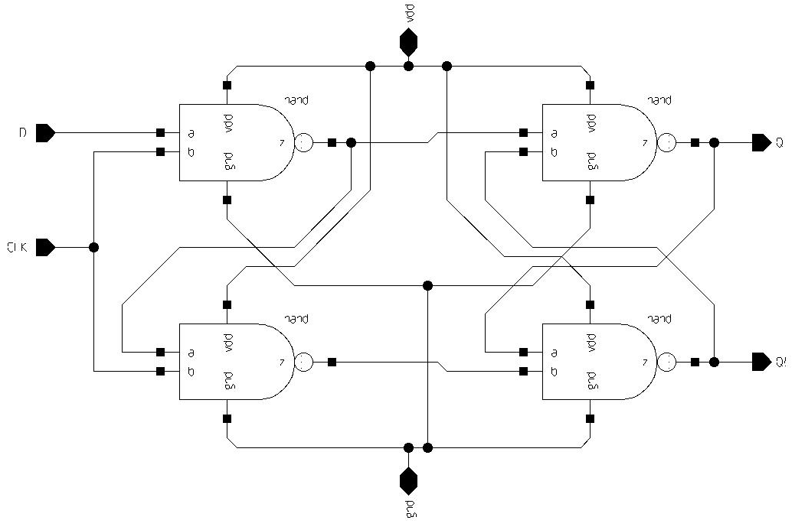

TEST BENCH

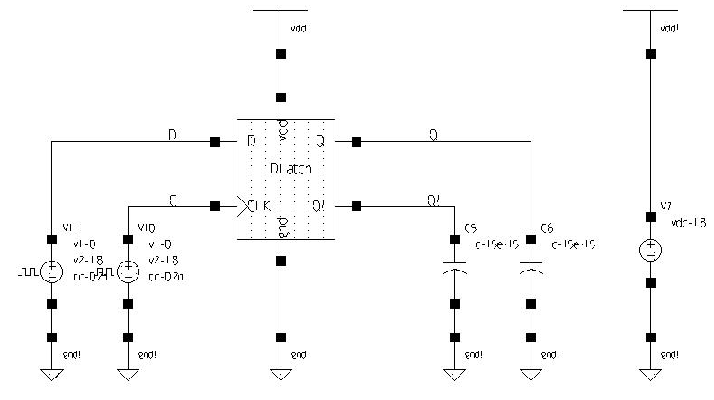

SIMULATION

